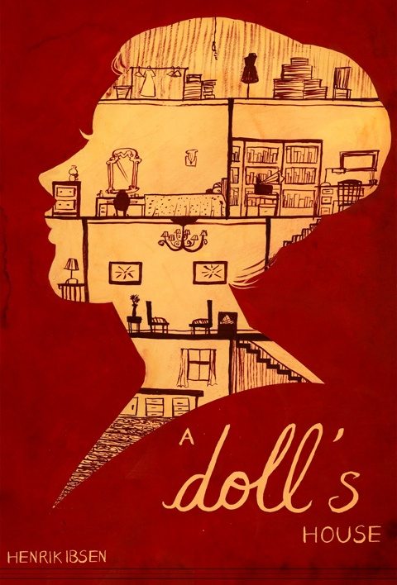

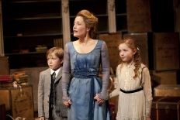 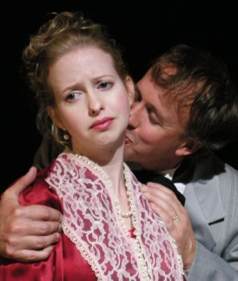

**Study Packet**

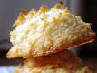SYMBOLISM IN *A DOLL’S HOUSE*

For each symbol listed below, please write words and phrases that demonstrate the meaning of each symbol. Include the Act number, line, and page number of proof for each symbol. Write a brief interpretation of each symbol.

**Symbol Words/Phrases Proof Interpretation**

|  |  |  |  |
| --- | --- | --- | --- |
| **macaroons** |  |  |  |
| **letter** |  |  |  |
| **tarantella** |  |  |  |
| **Locked mailbox** |  |  |  |
| **Christmas tree** |  |  |  |
| **Doll house** |  |  |  |
| **pet names (squirrel, bird)** |  |  |  |

***A Doll’s House* Monologue Analysis**

A monologue is a long speech by one character. A monologue can be spoken by a character while speaking to himself or can be spoken to another person.

Identify a monologue by Torvald and one by Nora. Analyze the monologue and discuss how the monologue describes the character and what it says about the character’s development through the play.

|  |  |
| --- | --- |
| **Torvald**  Page Number:  Monologue: | Analysis of monologue |
| **Nora**  Page Number:  Monologue: | Analysis of monologue |

Analysis

Directions: Record your thoughts and be prepared to defend them in class. This is not an essay, but rather a note-taking assignment. Be sure to include lines from play to support your analysis.

*When Nora submits to Torvald, telling him, “whatever you do is always right,” Torvald replies, “Now my little lark’s talking like a human being.” But later, Nora says, “Before all else, I’m a human being.” Compare and contrast Torvald’s and Nora’s definitions of “human being”.

*Mrs. Linde tells Krogstad, “I’ve learned to be realistic. Life and hard, bitter necessity have taught me that.” How is *A Doll’s House* a realistic play? First, define realism as it applies to literature. Do a bit of research of how *A Doll’s House*  help define the realistic movement in drama.